Sheet 3

- Consider a discrete-time signal, fed as input into a system. The system produces the discrete-time output such that:
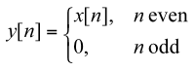

- Is the system described above memoryless? Explain.
- Is the system described above causal? Explain.
- Are causal systems in general memoryless? Explain.
- Is the system described above linear and time-invariant? Explain

- State with a brief explanation if the following systems are linear/non-linear, causal/non-causal, timeinvariant/time-varying.

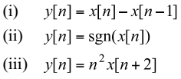

- State with a brief explanation if the following systems are linear/non-linear, causal/non-causal, timeinvariant/time-varying.

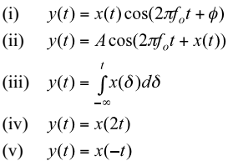

- Show that the system described by the equation $y_{\left(t\right)}=x_{(t)}^{2}$ is not invertible but BIBO stable.
- Is these systems are invertible or no?
- y(t) = x(t+2)
- y(t) = (cos(t)+2) x(t)

Dr. Michael Nasief
Eng. Mohamed Elsayed

